**Lab3**

**The main idea of this assignment is to provide hands on experience on the following topics Grep**

**Pipe**

**redirection read**

**command Line arguments head,tail,tr**

1. **Create a file “poem.txt” with the following lines**

**We have not wings, we cannot soar; But we have feet to scale and climb By slow degrees, by more and more, The cloudy summits of our time.**

**The mighty pyramids of stone**

**That wedge-like cleave the desert airs, When nearer seen and better known, Are but gigantic flights of stairs.**

**The distant mountains, that uprear Their solid bastions of the skies,**

**Are crossed by pathways that appear As we to higher levels rise.**

**The heights by great men reached and kept Were not attained by sudden flight,**

**But they, while their companions slept, Were toiling upward in the night.**

**END**

**Henry Wadsworth Longfellow (1807–1882) was an American poet and educator.**

**Do the following task using grep command**

* 1. **Print all the lines with the pattern “they”**

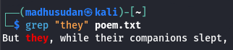

* 1. **Print all the lines other than pattern “They”**

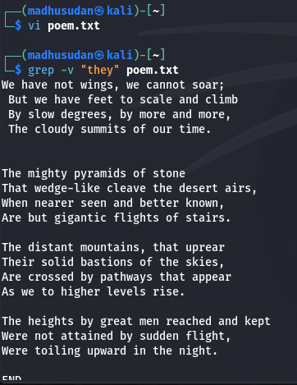

* 1. **Print all the lines starts with “w”**

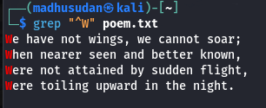

* 1. **Print the next lines after the pattern “stone” matches Hint: man grep**

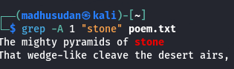

* 1. **Print the 2 lines above the pattern “stone” matches Hint: man grep**

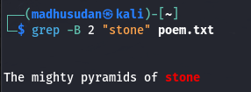

1. **Explore variations of grep command**

**ngrep - Used for network packet filtering based on pattern matches.**

**pgrep - Searches for processes matching a pattern.**

**zgrep - Searches within compressed files.**

**egrep - Extended grep allowing additional regular expressions like +, |, etc.**

1. **Write a shell script to get the pattern and filenames from the user and check whether the pattern is present or not.**

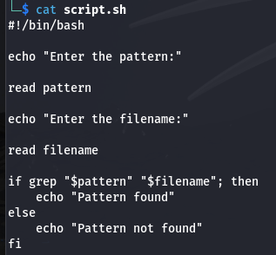

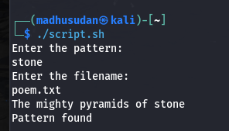

1. **Rewrite the above shell script using command line arguments. ( pass the pattern and file through command line arguments)**

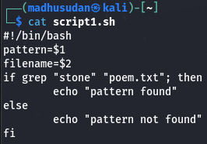

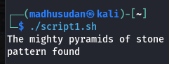

1. **Write a shell script to count total number of regular files in the current working directory.**

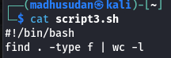

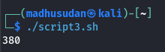

1. **pipe**
2. **Pick the line from 3 to 5.**

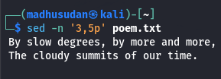

1. **List the top 5 largest files in a directory and display their sizes**

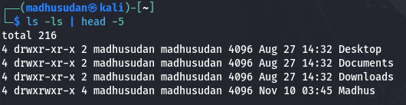

1. **Print the last 2 modified file details**

